
A14
Sreenidhi Institute of Science and Technology
(An Autonomous Institution)
Code No: 4B305
B. TECH. II-Year I-Semester Examinations, December 2015 (Regular)
MECHANICS OF SOLIDS (ME)

Time: 3 Hours Max. Marks: 70

Note: No additional answer sheets will be provided.

Part - A
Max.Marks:20

Answer all QUESTIONS. EACH QUESTION CARRIES 2 MARKS.
1. Define Hooke’s law and mention its assumptions.
2. State the applications of Mohr’s circle.
3. Write the relationship between shear force, bending moment and rate of Loading.
4. Define the terms neutral axis and section modulus.
5. Derive the relationship between slope, deflection and radius of curvature of a beam.
6. Define the terms longitudinal stress and circumferential stress. Also write the formulae related to them.
7. What is meant by the terms resilience and proof resilience ?
8. Draw the shear force and bending moment diagram for a simply supported beam carrying a uniformly distributed load of W kN/m over its entire length.
9. State the important steps in Moment Area Method.
10. What is Lame’s equation?
Part – B
Max.Marks:50
ANSWER ANY FIVE QUESTIONS. EACH QUESTION CARRIES 10 MARKS.

1. a. Draw stress - strain curve for a mild steel rod subjected to tension and explain about the salient
points on it. [3M]

b. Three bars made of copper; zinc and aluminium are of equal length and have cross section 500, 700 and 1000mm² respectively. They are rigidly connected at their ends. If this compound member is subjected to a longitudinal pull of 250 kN, estimate the proportional of the load carried on each rod and the induced stresses. Take the value of E for copper = 1.3×10 ⁵ N/mm², for zinc = 1×10⁵ N/mm² and for aluminium = 0.8×10⁵ N/mm². [7M]

2. a. Define principal plane and principal stresses. [2M]
b. Draw the Mohr’s Circle for the stress element shown in Fig. 1 below. Determine the
Principal stresses and Maximum Shear Stresses. [8M]
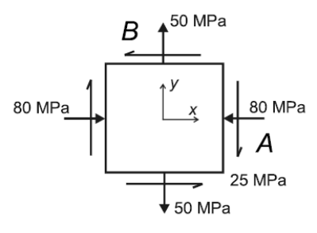
Fig.1

3. Draw shear force and bending moment diagram for the beam shown in Fig.2
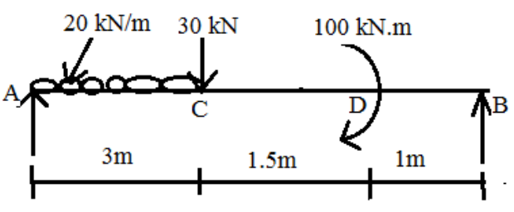
Fig. 2
4. The shear force acting on a section of beam as shown in Figure. 3. is 50 KN. The moment of inertia about the horizontal neutral axis is 314.221 x 10⁴ mm⁴. Calculate the shear stress at the neutral axis and at the junction of the web and the flange.
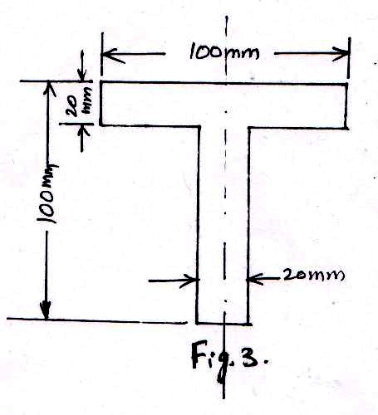
5. For the beam shown in Fig 4. show that the deflection at the free end is WL⁴/684EI. Use Macaulay’s method.
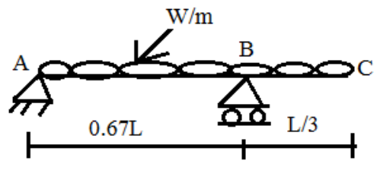
Fig.4
6. Determine the maximum and minimum hoop stress across the section of a pipe of 400 mm internal diameter and 100 mm thick, when the pipe contains a fluid at a pressure of 8 N/mm². Also sketch the radial pressure distribution and hoop stress distribution across the section.

7. Draw the shear force and bending moment diagram for the beam shown in Fig.5 below
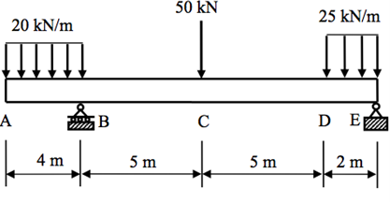
Fig.5
8. a) From fundamentals derive the bending equation used in theory of simple bending.
b) Derive Lame’s theorem for thick cylinders.
-- 00 -- 00 --

